**Task Overview**

The task is to build from the mocup supplied the test page as a fully responsive webpage. We have added into the mockup a table for call records, we'd like you to populate that table through importing the data in the CSV file, you can do this direct from the file or convert the file into JSON if you prefer working with JSON. We would also like JS show/hide accordion functionality added to the button in the mockup, that will display and then hide the table as it is clicked.

The mockup shows you the table column, you just need to add in the remaining data.

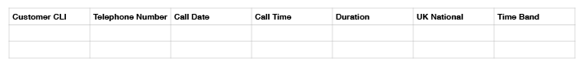

**Extra Credit**

Build the tests you would build for this page to show the functionality has been correctly developed.